

Village of Northport, MI

Water Cost of Service Study

September 12, 2024




Submitted Respectfully by:
Dawn Lund, Vice President
Utility Financial Solutions, LLC
dlund@ufsweb.com
(231) 218-9664



September 12, 2024

Mr. Jim Dyer
Village Manager
Village of Northport
116 West Nagonaba
P.O. Box 336
Northport, MI 79670

Dear Mr. Dyer,

We are pleased to present this executive summary report for a cost of service, financial projection and rate design study completed for the Village of Northport Water Department. This report was prepared to provide the utility with a comprehensive examination of its existing financials by an outside party.

The specific purposes of this long-term financial projection and rate study are:
- Determine the water utility’s revenue requirements for 2025
- Project rate adjustments needed to work toward targeted revenue requirements

This report includes results of the cost of service, financial projection, and identifies the future rate track for the Water operation. Specific findings included in this report are:
- Rate adjustments that are based on the utility’s ability to work toward three factors listed below:
  - Debt Coverage Ratio
  - Minimum Cash Reserves
  - Optimal Operating Income

This report is intended for information and use by management and the governing body for purposes stated above and is not intended to be used by anyone except the specified parties.

Sincerely,

Dawn Lund

Utility Financial Solutions, LLC
Dawn Lund, Vice-President

Executive Summary | Page
Water Operation
Utility Revenue Requirements | 2
Revenue Forecast | 7
Summary of Financial Position | 8
Proposed Rate Track | 8
Cost of Service Results | 9
Water Operation Findings | 11
Appendix – Proposed Rate Design and Impacts | i

Utility Revenue Requirements

Revenue requirements for the Water Department were projected for 2025 based on Fiscal Year 2023 actual and Budget 2025. Revenues and expenses were analyzed, with adjustments made to reflect projected operating characteristics. Table 1 below summarizes the significant assumptions used in the projection. The projected financial statements are for cost of service purposes only.

Table 1 – Financial Projection Significant Assumptions

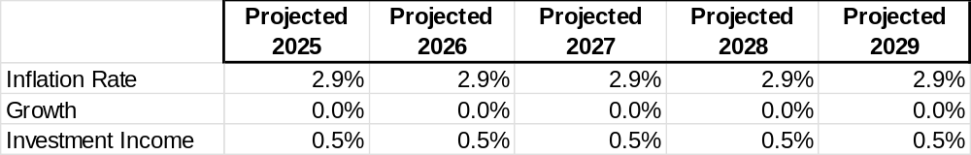

Table 2 below is the projected financial summary for the Water Department from 2025-2029 without rate adjustments. The projection includes bond issues of $536,942 (total of capital improvements 2025-2027) in 2025 and $760,000 in 2029 for the projected capital improvement plan. Projected operating income is forecasted at a loss of ($10,979) in 2025. Operating losses are expected to increase to ($70,645) by 2029. Projected cash balance declines throughout the projection period to ($208,887) in 2029. Debt coverage ratios do not meet targeted minimums throughout the projection period.

Table 2 – Financial Projection Summary (Without Rate Adjustments and With Bond Issues)

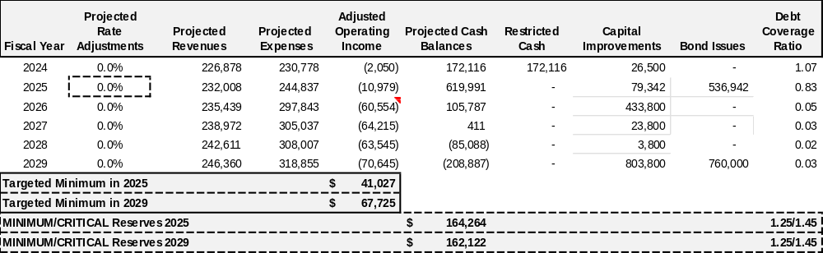
- The five-year capital improvement plan was provided by the Utility.
- Financial projections should be updated during the budgeting process each year as expenses and capital expenditures change from projections.

Projected Cash Flow

Table 3 is the projected cash flow for 2025-2029, including projections of capital improvements as provided by the Utility as well as bond issues in 2025 and 2029. Changes in the capital improvement plan can greatly affect the cash balance and minimum cash reserve target. The minimum the utility should hold is approximately $160,000.

Table 3 - Projected Cash Flows (Without Rate Adjustments; With Bond Issues)

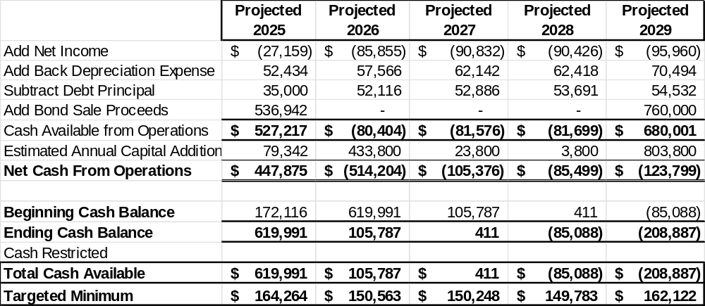

Projected Cash Balances do not meet targeted minimums starting in 2026.

Development of Financial Targets

When evaluating rates to charge customers, three factors must be considered:
- Debt Coverage Ratio
- Minimum Cash Reserves
- Optimal Net Income

Each of these factors is discussed below:

Debt Coverage Ratio - The minimum targeted debt coverage ratio for prudent financial planning purposes is 1.45 for revenue bonds. Maintaining a 1.45 debt coverage ratio is good business practice and would help to achieve the following:
  - Helps to ensure adequate funds are available to meet debt service payments in years when sales are low due to cold or wet summers or loss of a major customer(s).
  - Obtain higher bond rating, if revenue bonds are sold in the future, to lower interest cost.

Table 4 is the debt coverage ratios projected for 2025-2029. This projection includes bond issues of $536,942 in 2025 and $760,000 in 2029.

Table 4 – Projected Debt Coverage Ratios (Without Rate Adjustments; With Bond Issues)

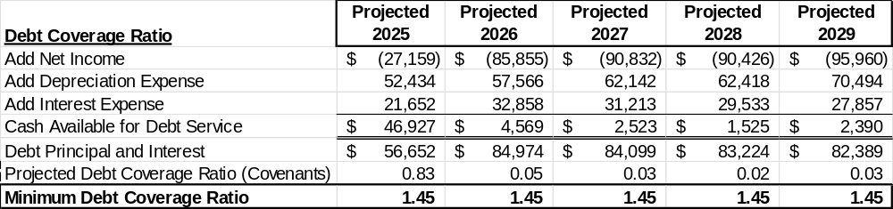

Debt Coverage Ratios do not meet minimum targets throughout the projection period.

Minimum Cash Reserve - Table 5 is the minimum level of cash reserves required to help ensure timely replacement of assets and to provide financial stability of the water utility. The table below is based on certain assumptions related to a percentage of operating expense, historical investment, capital improvements, and self-insurance. Minimum cash reserve attempts to quantify the minimum amount of cash the utility should keep in reserve and is considered at critical levels if cash approaches this minimum. Actual cash reserves may vary substantially above the minimum and are dependent on the life cycle of assets that are currently in service. The water utility should maintain a minimum of $160,000.

Table 5 – Minimum Cash Reserves (Without Rate Adjustments; With Bond Issues)

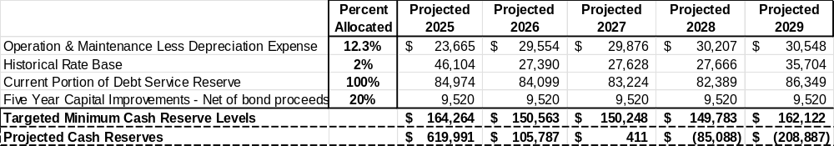

Projected Cash Reserves do not meet minimum levels starting in 2026 and include bond issues in 2025 and 2029.

Optimal operating income targets - The optimal target for setting rates is the establishment of a target operating income to help ensure the following:
- Funding of Interest Expense on the outstanding principal on debt. Interest expense is below the operating income line and needs to be recouped through the operating income balance.
- Funding of the inflationary increase on the assets invested in the system. The inflation on the replacement of assets invested in the utility should be recouped through the Operating Income
- Adequate rate of return on investment to help ensure current customers are paying their fair share of the use of the infrastructure and not deferring the charge to future generations.

As improvements are made to the system, the optimal operating income target will increase unless annual depreciation expense is greater than yearly capital improvements. The target established for 2025 is $41,027. The projected operating income was adjusted for contributed capital depreciation and is below the minimum throughout the projection period.

Table 6 – Rate of Return Calculation (Without Rate Adjustments; With Bond Issues)
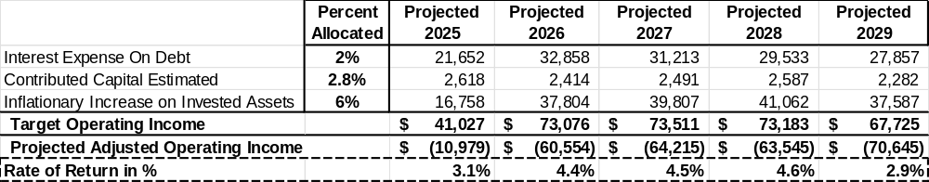
Projected Operating Income is below optimal targeted operating income levels throughout the projection.

Revenue Forecast:

Sales were projected and adjusted for known or anticipated changes in customer usage and growth for the projection period. Table 7 and 8 below projects the billed units and number of customers in 2025.

Table 7 – Projected Billed Units

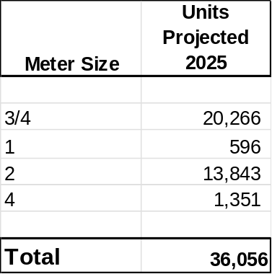

Table 8 – Projected Number of Customers

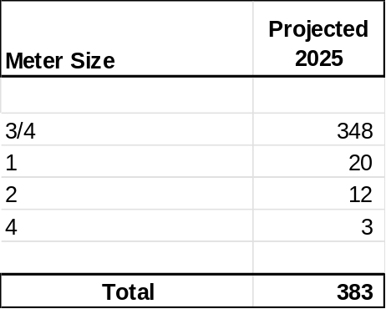

Summary of Financial Position

Proposed Rate Track – Test Year 2025
Increasing rates requires balancing the financial health of the utility and the financial impact on customers. Table 9 below is the five-year financial projection with rate increases of 20.0% in 2025-2028 and 10.0% in 2029. The projection includes a $536,942 bond issue in 2025 and $760,000 bond issue in 2029. The rate track was set to stabilize operating income, cash balance and debt coverage ratios. The rate track should be reviewed as part of the annual budget process as costs, revenues, growth, and capital may vary from projections.

Table 9 – Financial Projection Summary (With Rate Adjustments; With Bond Issues)

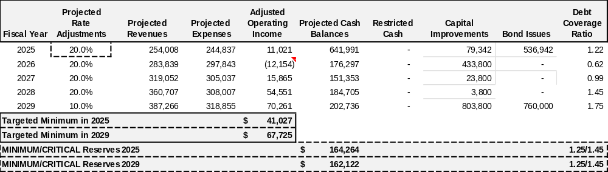

Cost of Service Results
The purpose of a cost of service study is to allocate costs between flow (Commodity Costs) and customer service costs (Customer Costs). The cost of service study was based on recognized procedures from the American Water Works Association.

Commodity Costs are costs that tend to vary with the quantity of water used, as well as costs associated with purchasing, pumping and distributing water to customers. Commodity costs include water purchase/treatment costs plus pumping stations and transmission lines.
Customer Costs are costs associated with serving customers regardless of their usage or demand characteristics. Customer costs include the operation and maintenance expenses related to meters and services, meter reading costs, billing and collection costs. The customer costs were allocated on the basis of the relative cost of meters and services and the number of customers.

Table 10 compares the current monthly service charges and current commodity charges with the results of the cost of service analysis. We do not recommend moving to the cost of service rates immediately, but working towards them over time to minimize the impact to customers. Please see the proposed rate design on page 12.

Table 10 – Comparison of Current Quarterly Charges with Cost of Service Charges

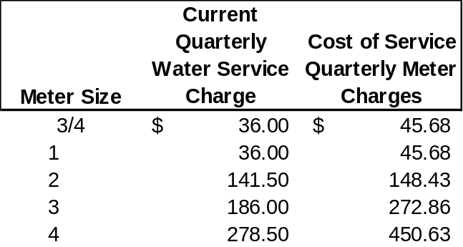
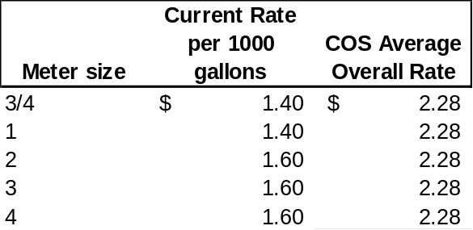

Significant Assumptions

This section outlines the procedures used to develop the cost of service study and rate design for the Water Utility the related significant assumptions.

Forecasted Operating Expenses
Forecasted expenses were based on 2023 actual and Budget 2025 and adjusted for inflation.

Inflation
Inflation was assumed at 2.9% in 2025-2029.

Interest Income

Interest income was forecasted based on projected cash balances and an interest rate of 0.5%.

Capital Improvements

The capital improvement projections were provided by the Utility. Projections for 2025-2029 are listed below:

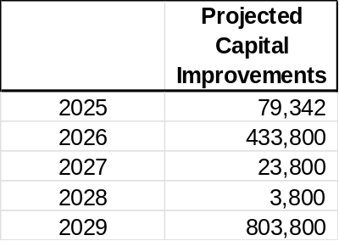

Water Operation Findings

- For the Village of Northport water operations to maintain long-term financial targets, rate increases should be considered. Below is a summary of the financial projection with proposed rate increases of 20.0% in 2025-2028 and 10.0% in 2029. The rate track should be reviewed as part of the annual budget process as costs, revenues, cash reserves, and capital may vary from projections.

- A cash reserve policy should be considered and updated each year with the budget process based on the following formula:

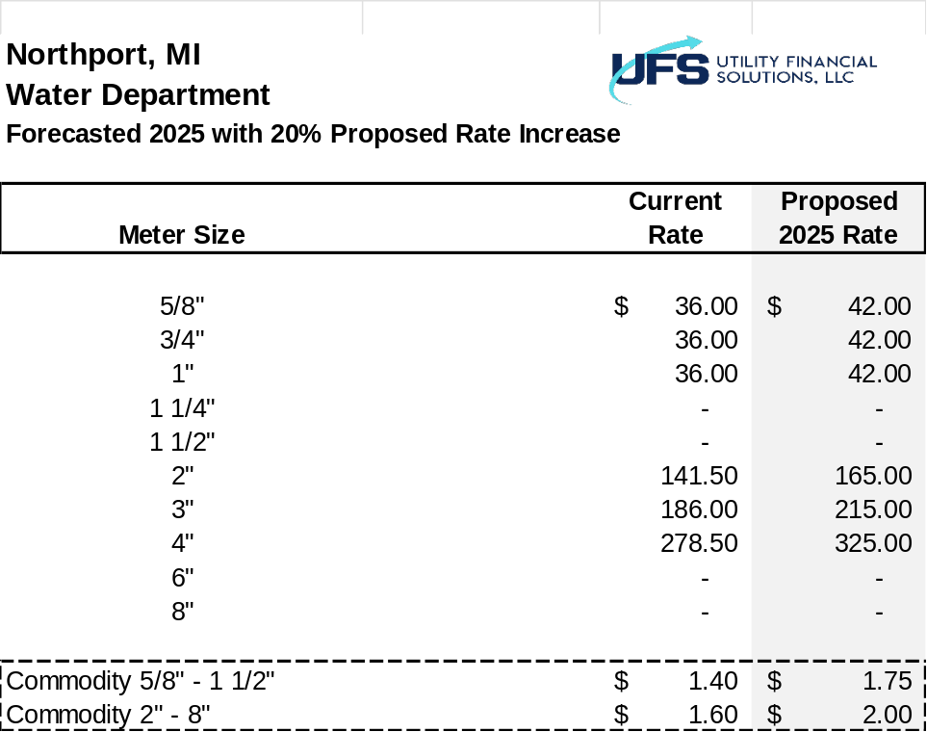

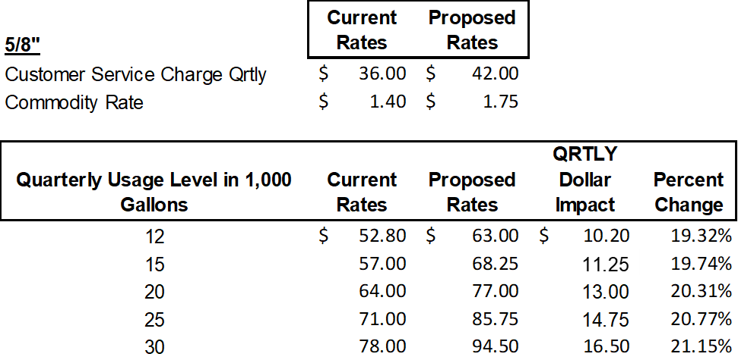
$11.25 per QRT = $3.75 per Month

