….…..Celebrate Arbor Day 2024………

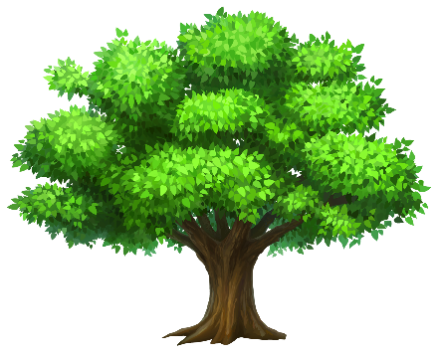

WHAT: Join the Tree Committee, students from Northport School, and fellow community members to recognize Arbor Day 2024 with the planting of a new tree.

WHEN: Friday, April 26, 2024, 10:00 a.m.

WHERE: Marina Park – South end near sailing school

QUESTIONS? Contact Bob Newell (313) 204-8312

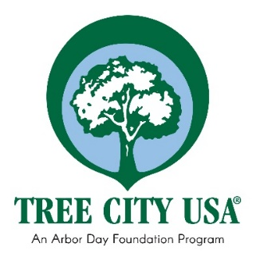

Sponsored by the Tree Committee of the Village of Northport Planning Commission

